Self-Balancing Robot

# 1- Hardware (3 options)

|  |
| --- |
| 1x Microcontroller |
| Arduino Uno/Nano/Mega |
| Comparación Arduino Uno – Arduino Nano | Robots Didácticos |

|  |
| --- |
| 2x Motors |
| BO Gear DC Motor |
| BO1 200RPM Plastic gear Motor : rhydoLABZ INDIA |

|  |
| --- |
| 1x Motor Drivers |
| L298N Motor Driver |
| Buy L298N 2A Motor Driver Module Online at the Best Price |

|  |
| --- |
| 1x Gyroscope/Accelerometer |
| MPU6050 GY-521 Module |
| Buy MPU6050 MPU-6050 GY-521 3 Axis analog gyro sensor + 3 ... |

|  |
| --- |
| 2x Wheels |
| BO Gear DC Motor Wheels |
| Car DC Motor and Wheel – Perintang.com |
| 1x Bluetooth Module (If Using Arduino) | |
| HC-05 Bluetooth Module | |
| Sensors Modules Bluetooth Module Hc 05 | Sensors Modules | |

|  |
| --- |
| Li-po Battery |
| LiPo Battery 12V 2200mAh |

# 2- Installation

## Installation with DC gear motors

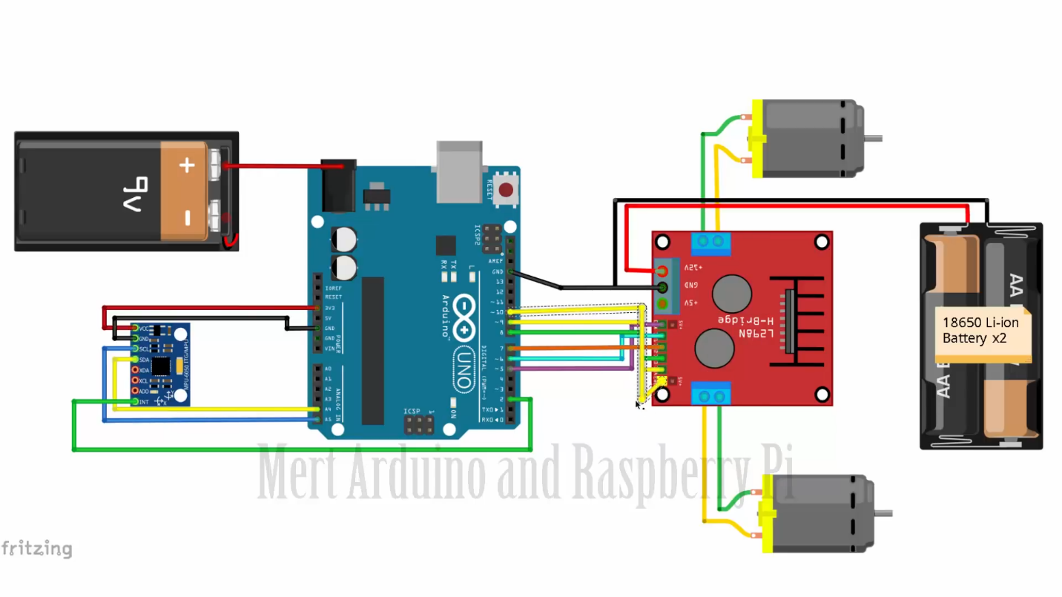

## Installation with stepper motors + Bluetooth module

